**Simple WebApi deployment onto IIS**

1. Create a web api in visual studio with “docker support” enabled. Right click on name of project and go to “Publish”.

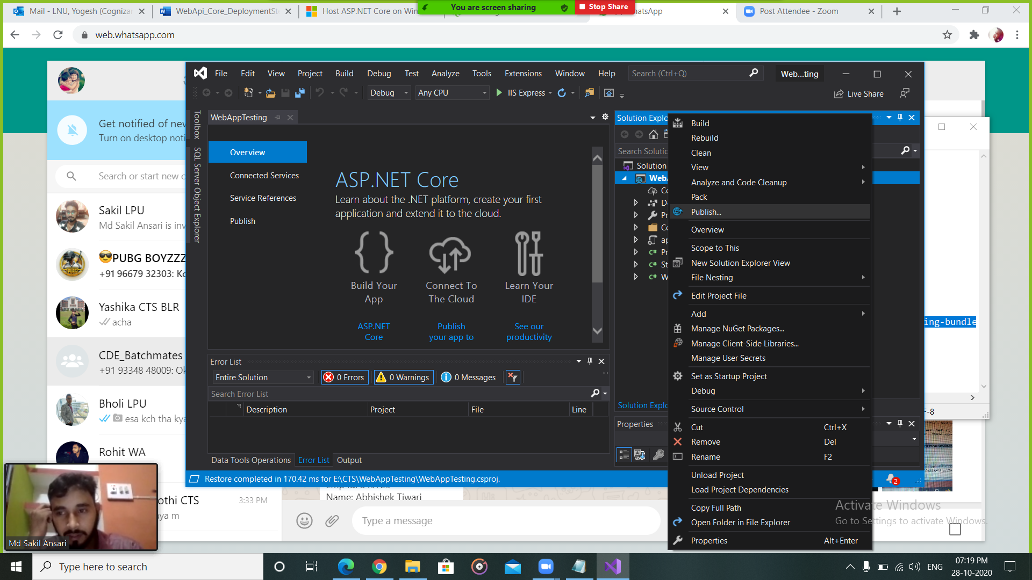

1. Choose the folder.

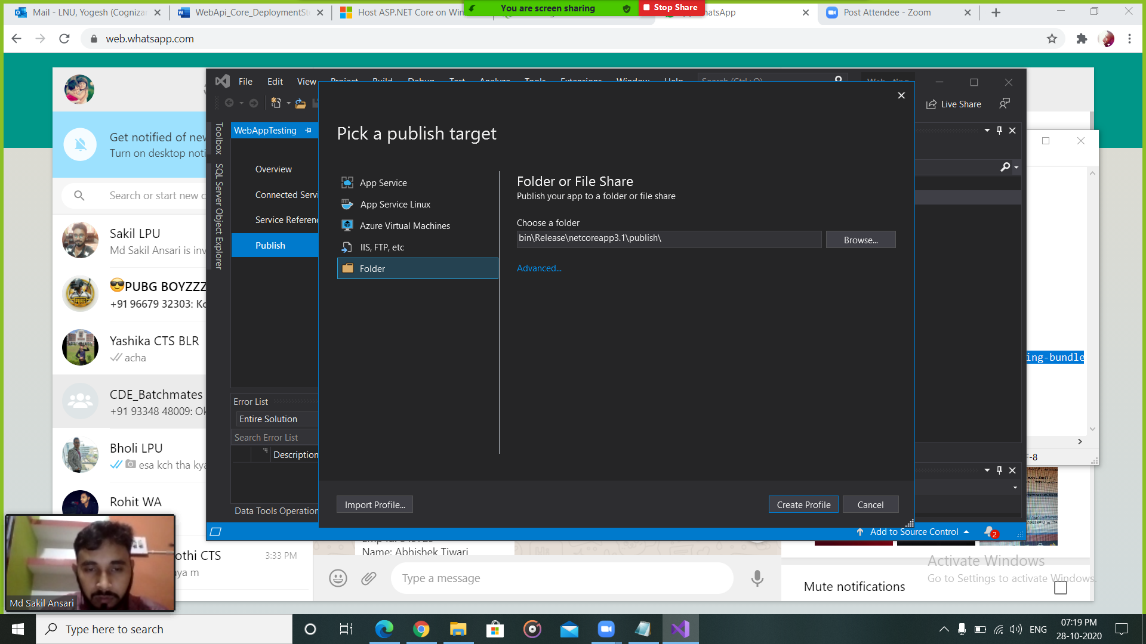

1. Select publish folder in project>bin>release>netcoreapp3.1

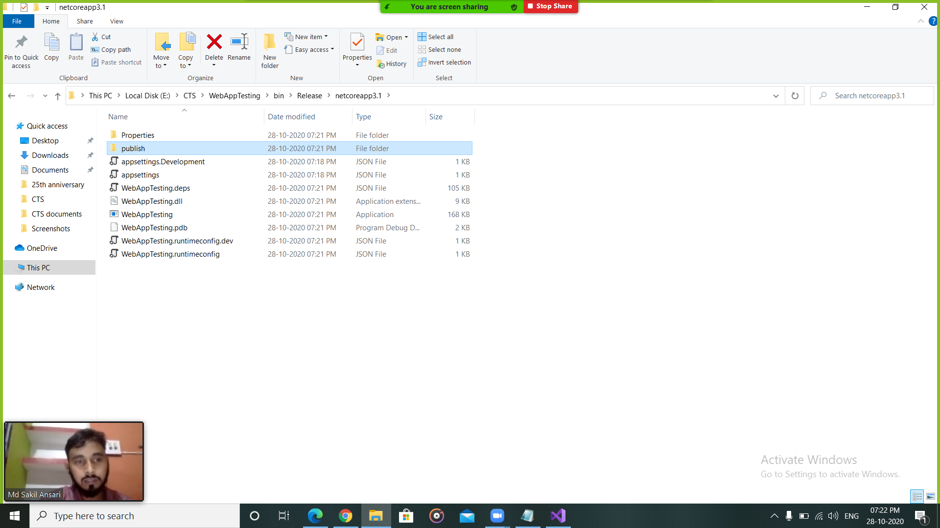

1. Copy publish folder and paste in the given folder.

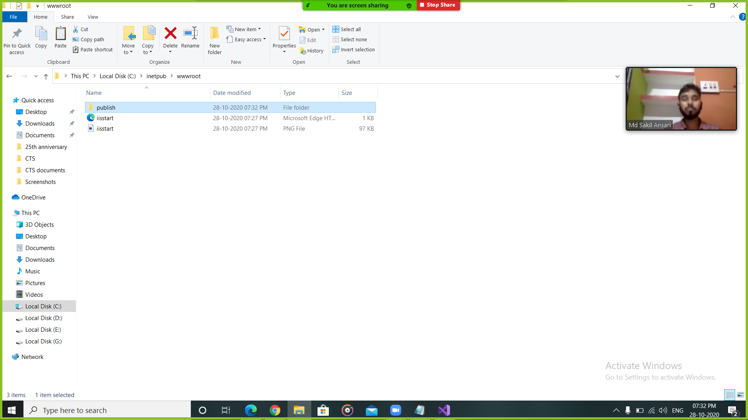

1. Open the IIS manager. Open “add website” as shown and add desired informations.

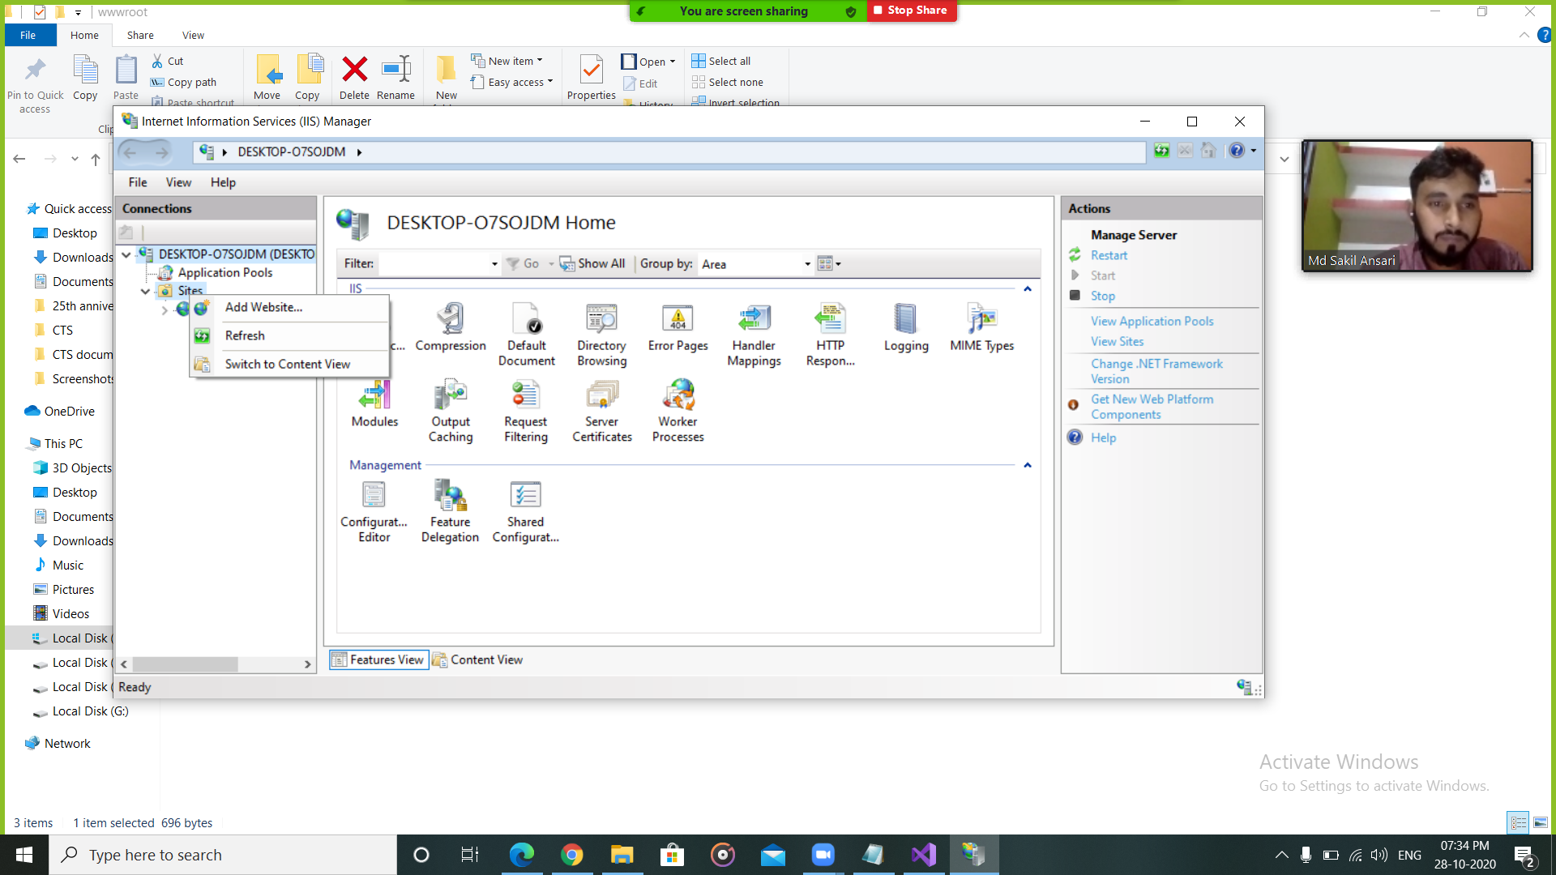

1. Now we can go to the website from IIS manager directly.

